***“WORLD WEATHER TRENDS”***

1. **LATITUDE VS.TEMPERATURE:**

Latitude provides the location of a place north or south of the equator and is expressed by angular measurements ranging from 0° at the equator to 90° at the poles. Different latitudes on Earth receive different amounts of sunlight, and are a key factor in determining a region’s climate. For example, the higher the latitude of a given place (the farther away it is from the equator), the sharper the angle of the sun’s rays that reach it, meaning that the rays of the sun are spread across a broader area. Therefore, higher latitudes receive less heat than lower latitude areas nearer the equator.

The tropical belt of land and sea extending around the globe on both sides of the equator – between 23.5S and 23.5N – receives the most sunlight, but it is not necessarily the hottest since it is covered extensively by oceans that use some solar energy for evaporation. This combination of high moisture and intensive solar heating results in a persistent zone of convection (the upward movement of moist, unstable air) known as a tropical low, which often results in generous cloud formation and frequent rainfall. These factors also help moderate the temperatures within this zone.

Our graph, in general, matches the predictions about trends of temperatures around equator. The temperatures are higher than the areas further away from the equator .But we also see lot of variation in temperature even at the same latitudes, indicating that there are other factors that affect temperature and climate of a place than the distance from the equator.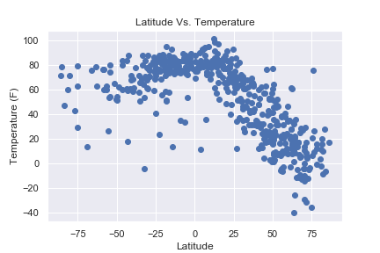

1. **LATITUDE VS.CLOUDINESS:**

It is predicted that Clouds tend to form in abundance in the middle latitudes 60 degrees north and south of the equator. This is where the edges of polar and mid-latitude (or Ferrel) circulation cells collide and push air upward, fueling the formation of the large-scale [frontal systems](http://www.metoffice.gov.uk/learning/learn-about-the-weather/how-weather-works/weather-fronts) that dominate weather patterns in the mid-latitudes. While clouds tend to form where air rises as part of atmospheric circulation patterns, descending air inhibits cloud formation. Since air descends between about 15 and 30 degrees north and south of the equator, clouds are rare and deserts are common at this latitude.

Our data does indicate this pattern with maximum cloudiness concentrated between -25 and +75 latitudes. The deviation from prediction may be seasonal and prevalent wind patterns.

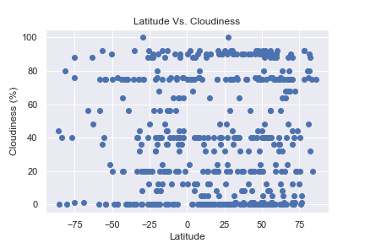

1. **LATITUDE VS.WIND-SPEED:**

**Some facts about wind to check:**

1. The horse latitudes are a narrow zone of warm, dry climates between westerlies and the trade winds. Horse latitudes are about 30 and 35 degrees north and south. Many deserts, from the rainless Atacama of South America to the arid Kalahari of Africa, are part of the horse latitudes. We do observe zones of low wind speed at these latitudes in our graph.
2. The strongest westerlies blow through the “Roaring Forties,” a wind zone between 40 and 50 degrees latitude in the Southern Hemisphere. There are areas of wind-speeds of >25mph at these latitudes.
3. The place where trade winds of the two hemispheres meet is called the intertropical convergence zone (ITCZ). The area around the ITCZ is called the doldrums. Prevailing winds in the doldrums are very weak, and the weather is unusually calm. We do clearly infer from our graph that wind speeds are the lowest at the equator, on an average.

